**Title:** BuffGrades

**Vision:** To show students hwo well they are doing, and how well they need to do to be successful.

**Who:** Michael Asnes, Nicholas Riffel, Nishesh Shukla, David Becker, Jeremy Chrestionson.

**Automated Tests:**

Test in progress:

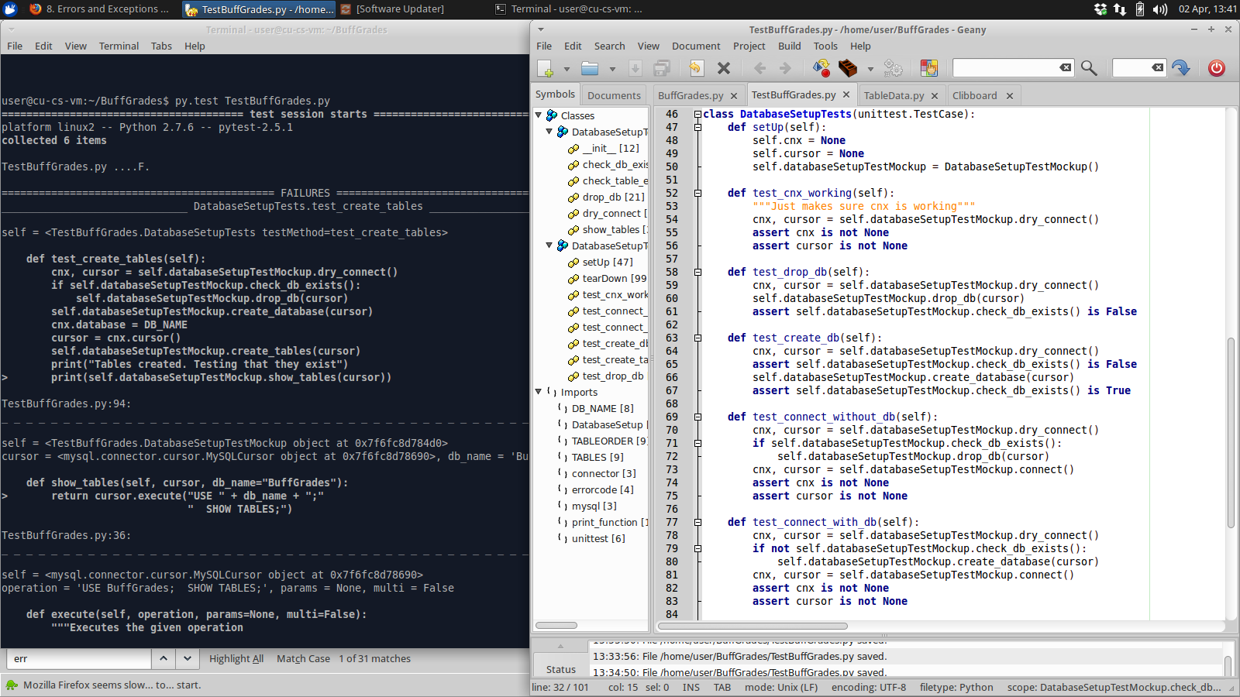

Results:

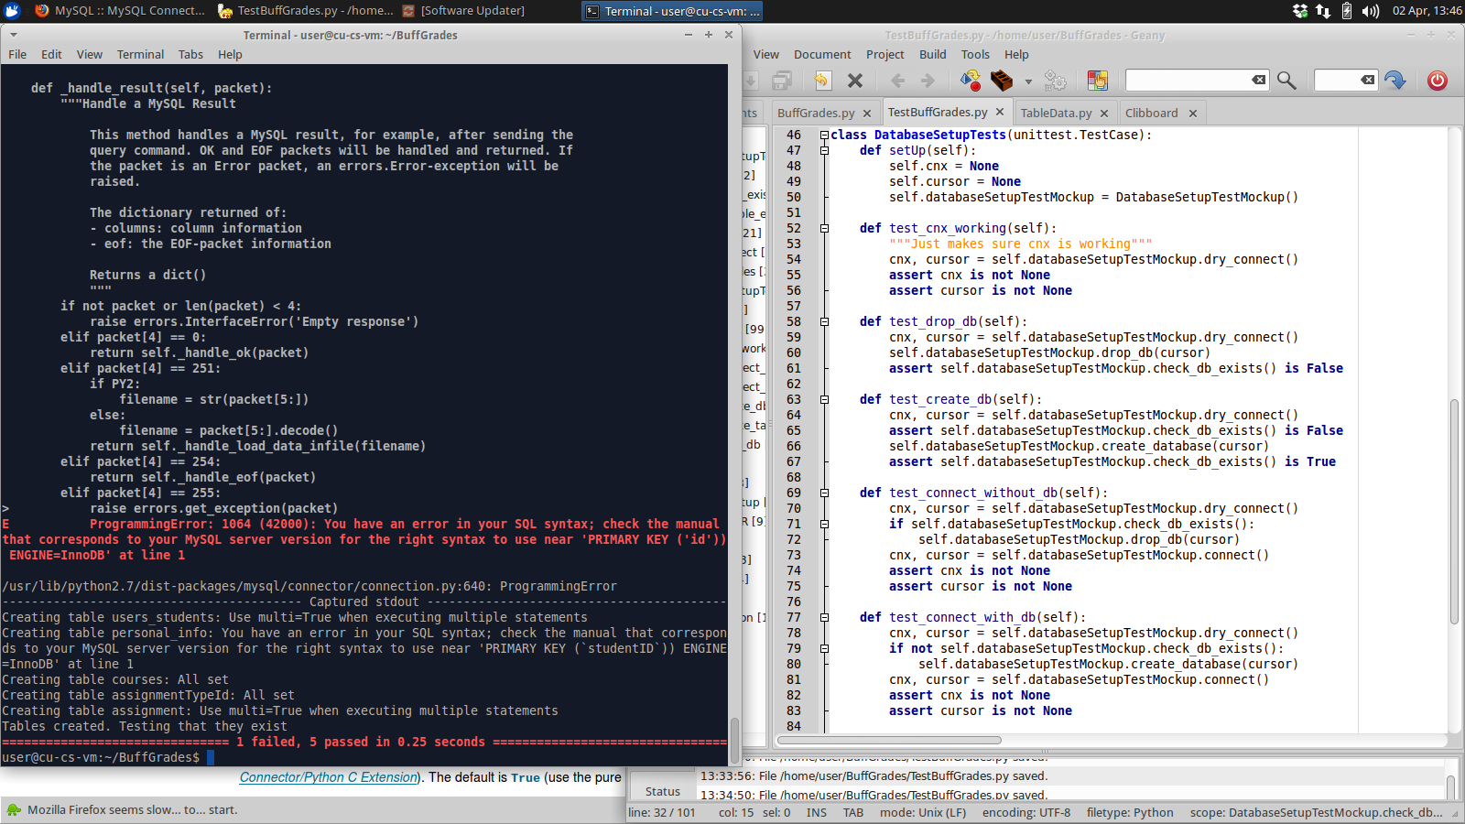

We used Py.test as our automatic testing software, and placed our test code into TestBuffGrades.py . We have written tests that check that the database was setup properly and that we can connect to it without any issues. Simply run

py.test testgrades.py after compiling and the tests should run.

**User Acceptance Tests:**

|  |  |  |  |  |  |  |
| --- | --- | --- | --- | --- | --- | --- |
| Project Name: Buff Grades | | | | | | |
| **User Acceptance Test Case 1** | | | | | | |
| Test Case ID: Sith_666 | | | | Test Designed by: Nicholas Riffel, Nishesh Shukla, Michael Asnes, David Becker, Jeremy Chrestionson | | |
| Test Priority (Low/Medium/High): High | | | | Test Designed date: 03/31/15 | | |
| Module Name: BuffGrades User Check | | | | Test Executed by: | | |
| Test Title: User Check | | | | Test Execution date: | | |
| Description: Making sure user is a verified user and has already inputted information, else queries for their information regarding classes and grades. | | | | | | |
|
|  | | | | | | |
| Pre-conditions: User has valid username | | | | | | |
| Dependencies: User has, or has not actually inputted information. | | | | | | |
|  | | | | | | |
| Step | Test Steps | Test Data | Expected Result | Actual Results | Status (Pass/Fail) | Notes |
| 1 | Open up GUI | Button Exists | It Opens GUI |  |  |  |
|  | | | | | | |
| Post Conditions: User is recognized by the application/GUI. | | | | | | |
|
|

|  |  |  |  |  |  |  |
| --- | --- | --- | --- | --- | --- | --- |
| Project Name: BuffGrades | | | | | | |
| **User Acceptance Test Case 2** | | | | | | |
| Test Case ID: Vader_667 | | | | Test Designed by: Nicholas Riffel, Nishesh Shukla, Michael Asnes, David Becker, Jeremy Chrestionson | | |
| Test Priority (Low/Medium/High): High | | | | Test Designed date: 03/31/15 | | |
| Module Name: User Data Input | | | | Test Executed by: | | |
| Test Title: Add A Course | | | | Test Execution date: | | |
| Description: User adds the name of a course that he/she is currently enrolled in. | | | | | | |
|
|  | | | | | | |
| Pre-conditions: GUI opened with verified user | | | | | | |
| Dependencies: | | | | | | |
|  | | | | | | |
| Step | Test Steps | Test Data | Expected Result | Actual Results | Status (Pass/Fail) | Notes |
| 1 | Click on "Add a Course" |  | Entry box appears |  |  |  |
| 2 | Enter the course name | "Test Course" | GUI displays "Test Course" under Courses |  |  |  |
|  |  |  |  |  |  |  |
|  |  |  |  |  |  |  |
|  | | | | | | |
| Post Conditions: Course is now saved within database | | | | | | |
|
|

|  |  |  |  |  |  |  |
| --- | --- | --- | --- | --- | --- | --- |
| Project Name:BuffGrades | | | | | | |
| **User Acceptance Test Case 3** | | | | | | |
| Test Case ID: Darth_668 | | | | Test Designed by: Nicholas Riffel, Nishesh Shukla, Michael Asnes, David Becker, Jeremy Chrestionson | | |
| Test Priority (Low/Medium/High): High | | | | Test Designed date: 03/31/15 | | |
| Module Name: User Data Input | | | | Test Executed by: | | |
| Test Title: Add Assignment Type | | | | Test Execution date: | | |
| Description: User adds an assignment type. | | | | | | |
|
|  | | | | | | |
| Pre-conditions: Test Course has been added | | | | | | |
| Dependencies: | | | | | | |
|  | | | | | | |
| Step | Test Steps | Test Data | Expected Result | Actual Results | Status (Pass/Fail) | Notes |
| 1 | Click "Add Assignment Type" |  | Entry box appears |  |  |  |
| 2 | Enter assignment type name | "Test Assignment Type" | GUI displays "Test Assignment Type" under Assignment Types. |  |  |  |
| 3 | Change "Test Assignment Type" Weight | "1.00" | "Test Assignment Type" Displays Weight of "1.00" |  |  |  |
|  |  |  |  |  |  |  |
|  | | | | | | |
| Post Conditions: GUI displays Test Assignment Type under Assignment Type. | | | | | | |
|
|

|  |  |  |  |  |  |  |
| --- | --- | --- | --- | --- | --- | --- |
| Project Name: BuffGrades | | | | | | |
| **User Acceptance Test Case 4** | | | | | | |
| Test Case ID: Yeah_669 | | | | Test Designed by: Nicholas Riffel, Nishesh Shukla, Michael Asnes, David Becker, Jeremy Chrestionson | | |
| Test Priority (Low/Medium/High): High | | | | Test Designed date: 03/31/15 | | |
| Module Name: User Data Input | | | | Test Executed by: | | |
| Test Title: Add Assignment | | | | Test Execution date: | | |
| Description: User adds assignments and grade of each assignment | | | | | | |
|
|  | | | | | | |
| Pre-conditions: User has Added Assignment Types | | | | | | |
|  | | | | | | |
|  | | | | | | |
| Step | Test Steps | Test Data | Expected Result | Actual Results | Status (Pass/Fail) | Notes |
| 1 | Click on "Add Assignment" |  | Entry box appears |  |  |  |
| 2 | Enter Assignment Name | "Test Assignment" | Test Assignment appears under Test Assignment Type |  |  |  |
| 3 | Enter Test Assignment Grade | "0.49" | "Test Assignment" Displays grade of "0.49". "Test Course" Displays grade of "0.49". |  |  |  |
|  |  |  |  |  |  |  |
|  | | | | | | |
| Post Conditions: GUI displays Test Assingment | | | | | | |
|
|

|  |  |  |  |  |  |  |
| --- | --- | --- | --- | --- | --- | --- |
| Project Name: BuffGrades | | | | | | |
| **User Acceptance Test Case 5** | | | | | | |
| Test Case ID: DidIt_700 | | | | Test Designed by: Nicholas Riffel, Nishesh Shukla, Michael Asnes, David Becker, Jeremy Chrestionson | | |
| Test Priority (Low/Medium/High):High | | | | Test Designed date: 03/31/15 | | |
| Module Name: Personal Overview | | | | Test Executed by: | | |
| Test Title: GPA Calculation | | | | Test Execution date: | | |
| Description: User determines the weight of the Assignment | | | | | | |
|
|  | | | | | | |
| Pre-conditions: User has created and set a grade for assignment. | | | | | | |
| Dependencies: GPA calculation algorithm | | | | | | |
|  | | | | | | |
| Step | Test Steps | Test Data | Expected Result | Actual Results | Status (Pass/Fail) | Notes |
| 1 | Click on "Overview" |  | GUI Displays Home page and GPA. |  |  |  |
|  |  |  |  |  |  |  |
|  |  |  |  |  |  |  |
|  |  |  |  |  |  |  |
|  | | | | | | |
| Post Conditions: User is able to ascertain what overall GPA is currently based on current classes entered and 4.0 scale. | | | | | | |
|
|

**VCS** (Link): <https://github.com/masnes/BuffGrades>